Par exemple
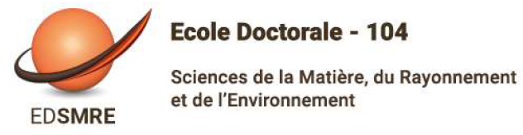

ETABLISSEMENT : ULille
Laboratory of affiliation : UMRt BioEcoAgro INRAe 1158
Scientific field, Speciality : Food Biotechnology, Food science, Physiology
Thesis director : Bruno Delbreil, Professor (ULille)
Co-supervisor : Isabelle Lejeune/Hénaut (INRAe) Benoit Mercatoris (Uliège), Pierre Delaplace (ULiège)
Planned co-funding : 50% Hauts de France / 50% INRAe (in progress)

Thesis title : Identification of relevant variables to assess the genetic variability of photosynthetic resilience in pea during cold acclimation.

Resume :
During our research on pea frost tolerance, results from "omics" approaches point to genes involved in photosynthetic activity during cold acclimation. To pursue genetic and breeding approaches, we need to identify precise and objective phenotyping variables associated with these mechanisms.
In the first part of the thesis, pea genotypes with contrasting cold acclimation and frost tolerance capabilities will be characterized using parameters derived from chlorophyll fluorescence imaging and hyperspectral imaging (reflectance).
The second part of the thesis aims to place the results of the first part in an environmental context representative of varietal selection in the field. Relay variables (fluorescence point, electrolyte leakage measurements) will be evaluated under controlled conditions and in the field to study correlations with frost tolerance on the one hand, and with imaging variables on the other.
All these data will be used to test the hypothesis of a sufficient differential, in the field, between tolerant and sensitive varieties for the fluorescence and reflectance variables most closely correlated with frost tolerance.

Required profile: The candidate should have a basic background in plant biology. He/she should be comfortable with the use of algorithms in the context of their learning mechanisms. Initial experience in plant experimentation would be an asset: design of experimental plans, observations and measurements, data processing and statistical analysis (R language).

Date de recrutement envisagée : 1st october 2024

Application form : CV, covering letter, academic transcript for the last two years. Proof of English language proficiency. Applications will be accepted until 19 may 2024.

Envoi des dossiers : isabelle.lejeune-henaut@inrae.fr

